



SUBMITTED TO:

SUBMITTED BY:

DANISH ZULFIQAR
REGISTRATION NO.:

FA21-BEE-042
SEMESTER-SECTION:

5-
B
COURSE:

EEE 462
Lab Report 01
BS Electrical Engineering
DR. DILSHAD SABIR
Artificial Intelligence

Lab 01 Introduction to Python

Lab Tasks:
Task 1:
Display numbers on screen using Python IDLE. Solution:
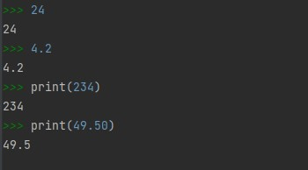

Task 2:
Display strings on screen.

Solution:
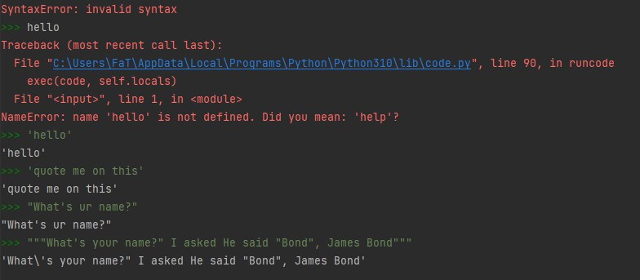

Task 3:
Use Python as a calculator.

Solution:

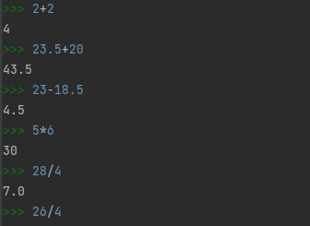

Task 4:
Get an integer answer from division operation. Also get remainder of a division operation in the output.

Solution:
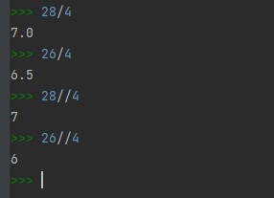
Task 5:
Calculate 43, 410, 429, 4150, 41000

Solution:
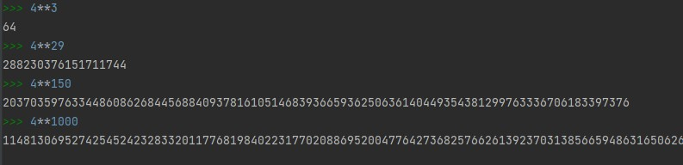

Task 6:
Write following math expressions. Solve them by hand using operators’ precedence. Calculate their answers using Python. Match the results.

Solution:
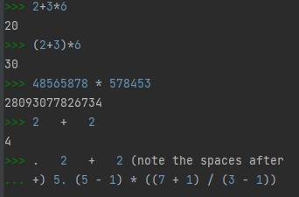

Task 7:
Combine numbers and text. Solution:

Command
# Text x = "Nancy" print(x)
# Combine numbers and text
s = "My lucky number is %d, what is yours?" %7 print(s)
# alternative method of combining numbers and text
s = "My lucky number is " + str(7) + ", what is yours?"
print(s)

Output:
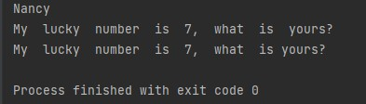

Task 8:
Take input from the keyboard and use it in your program.

Solution:
Command
name = input('What is your name? ')
print('Hello ' + name)
job = input('What is your job? ')
print('Your job is ' + job)

Output:
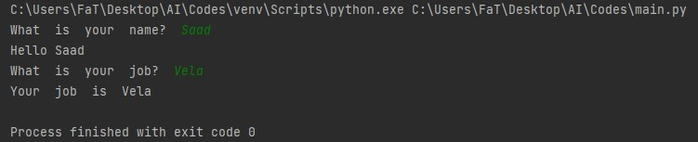

Task 9:
Let us take an integer from user as input and check whether the given value is even or not.

Solution:
Command
n=input("Enter a number = ")
if int(n)%2==0:
print("The given Number is even")
Output:
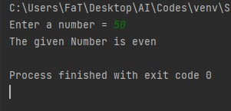

Task 10:
Let us modify the code to take an integer from user as input and check whether the given value is even or odd. If the given value is not even then it means that it will be odd. So here we need to use if-else statement an demonstrated below.

Solution:
Command
n=input("Enter a number = ")
if int(n)%2==0:
print("The given Number is even")
else:
print("The given Number is odd")

Output:
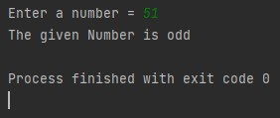

Task 11:
Calculate the sum of all the values between 0-10 using while loop.

Solution:
Command
summation=0
i=1
while i<=10:
summation=summation+1
i=i+1
print("The sum is = ", summation)

Output:
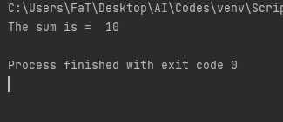

Task 12:
Accept 5 integer values from user and display their sum. Draw flowchart before coding in python.
Solution:
Command
i=0 while i<=4:
s=input("Enter Number: ")
n=int(s)
summ=summ+n
i=i+1
print("Summ is = ", summ)
Output:
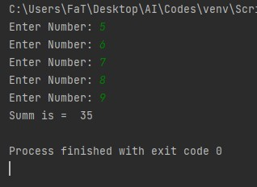

Task 13:
Write a Python code to keep accepting integer values from user until 0 is entered. Display sum of the given values.
Solution:
Command
sum=0
s=input("Enter an integer value : ")
n=int(s)
while n!=0:
sum=sum+n
s=input("Enter an integer value : ")
n=int(s)
print("The sum of given values is = ", sum)

Output:
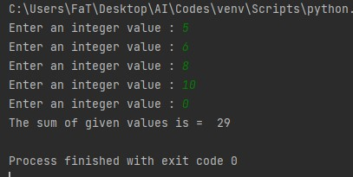
Task 14:
Write a Python code to accept an integer value from user and check that whether the given value is prime number or not.

Solution:
Command
isp=True
i=2
n=int(input("Enter a Number "))
while i<n:
rem=n%i
if rem==0:
isp=False
break
else:
i=i+1 if isp:
print("Number is Prime")
else:
print("Number is not Prime")

Output:
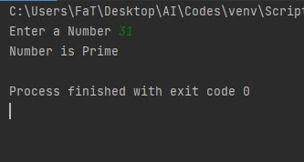

Post Lab:
Task 1:
Write a Python code to accept marks of a student from 1-100 and display the grade according to the following formula.

Grade F if marks are less than 50 Grade E if marks are between 50 to 60
Grade D if marks are between 61 to 70 Grade C if marks are between 71 to
80 Grade B if marks are between 81 to 90
Grade A if marks are between 91 to 100 Code:
s=1
while s<=100:
abc="Enter Marks Obtained for Student %d" %s
avg=int(input("Marks: "))
s=s+1
if avg>=91 and avg<=100:
print("Your Grade is A")
elif avg>=81 and avg<91:
print("Your Grade is B")
elif avg>=71 and avg<81:
print("Your Grade is C")
elif avg>=61 and avg<71:
print("Your Grade is D")
elif avg>=50 and avg<61:
print("Your Grade is E")
elif avg<50:
print("Your Grade is F")
else:
print("Invalid Input!")

Output:
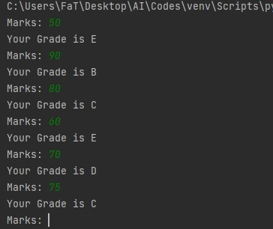
Task 2:
Write a program that takes a number from user and calculate the factorial of that number. Code:
num=int(input("Enter a number to calculate the factorial of: "))
factorial = 1
if num < 0:
print("Sorry, factorial does not exist for negative numbers")
elif num == 0:
print("The factorial of Ois 1")
else:
for i in range(1, num + 1):
factorial = factorial*i
print("The factorial of", num, "is", factorial),

Output:
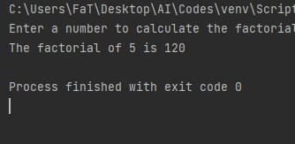

Assignment:
Fibonacci series is that when you add the previous two numbers the next number is formed. You have to start from 0 and 1.
E.g. 0+1=1 → 1+1=2 → 1+2=3 → 2+3=5 → 3+5=8 → 5+8=13 So the series becomes
0 1 1 2 3 5 8 13 21 34 55 ……………………………………
Steps: You have to take an input number that shows how many terms to be displayed. Then use loops for displaying the Fibonacci series up to that term e.g. input no is =6 the output should be
0 1 1 2 3 5

Code:
nterms = int(input("How many terms? "))
n1, n2 = 0, 1
count = 0
if nterms <= 0:
print("Please enter a positive integer")
elif nterms == 1:
print("Fibonacci sequence upto",nterms,":")
print(n1)
else:
print("Fibonacci sequence:")
while nterms > count:
print(n1)
nth = n1 + n2
n1 = n2
n2 = nth
count += 1

Output:
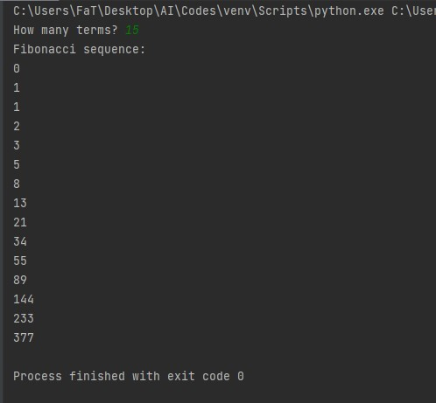

Critical Analysis and Conclusion:
In this lab I was introduced to Python Language. I learnt basic programming commands i.e arithmetic, print scan, loops etc and I was able to become familiar with them. Python is a powerful and easy to programable language. It has various number of use cases in machine learning and AI.

